Chapter 4, Solution 68.

Compute the value of R that results in maximum power transfer to the 10-Ω resistor in Fig. 4.134. Find the maximum power.

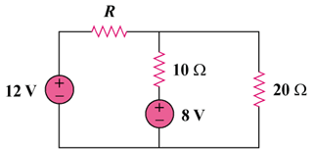

Figure 4.134
For Prob. 4.68.

Solution

This is a challenging problem in that the load is already specified. This now becomes a "minimize losses" style problem. When a load is specified, and internal losses can be adjusted, then the objective becomes, reduce R_{Thev} as much as possible, which will result in maximum power transfer to the load.
-
+
-
+

R

12 V

20 Ω

10 Ω

8V

Removing the 10 ohm resistor and solving for the Thevenin Circuit results in:

R_{Th} = (Rx20/(R+20)) and a V_{oc} = V_{Th} = 12x(20/(R +20)) + (-8)

As R goes to zero, R_{Th} goes to zero and V_{Th} goes to 4 volts, which produces the maximum power delivered to the 10-ohm resistor.

P = vi = v²/R = 4x4/10 = 1.6 watts

Notice that if R = 20 ohms which gives an R_{Th} = 10 ohms, then V_{Th} becomes -2 volts and the power delivered to the load becomes 0.1 watts, much less that the 1.6 watts.

It is also interesting to note that the internal losses for the first case are 12²/20 = 7.2 watts and for the second case are = to 12 watts. This is a significant difference.

